Elec 4700

The Physics and Modeling of Advanced Devices and Technologies

Circuit Modeling

Submitted By: Peter Al-Ahmar

Student Number: 100961570

Date Submitted: April 4th, 2019

The C and G matrixes that were created can be seen in figure 1 below.

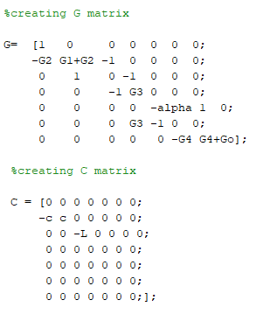

*Figure 1: C and G matrix that were created in Matlab*

Next A DC sweep was done on the voltages at node Vo and at V3. The resulting plot can be seen in the figure below.

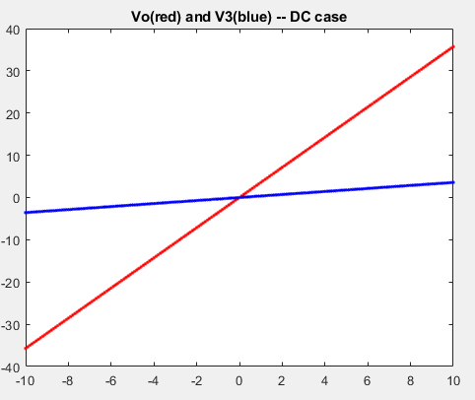

*Figure 2: DC sweep at Node Vo and V3*

Vo in the AC case was then plotted. Vo was plotted along omega in rad/s, then Vo in dB was plotted along omega in rad/s. That can be seen in the figure 3 and figure 4 respectively.

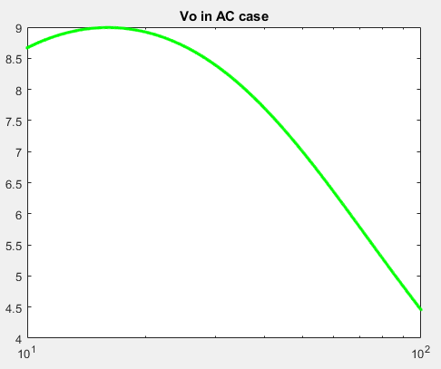

*Figure 3: Vo in AC across omega*

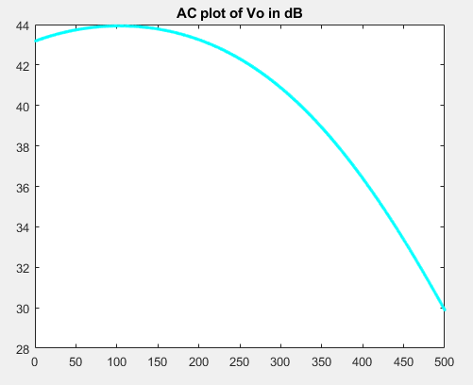

*Figure 4: Ac plot of Vo in dB across omega*

Histogram plot of random perturbations with a normal distribution was plotted next. It can be seen in the figure below.

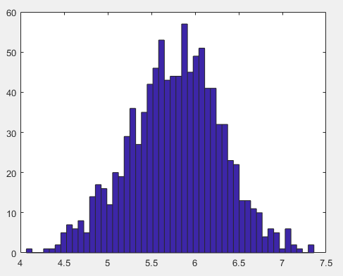

*Figure 5: Histogram plot of 1000 occurrences*

Question2

1. This is an RLC circuit
2. A band pass filter is expected, with a low and a high cut off frequency.
3. Three input signals were used in the following section, the first was step with the use of 1000 steps, next a sin input and finally a gaussian pulse with a magnitude of 1. The plots below show the use of each input and the resulting plots generated.

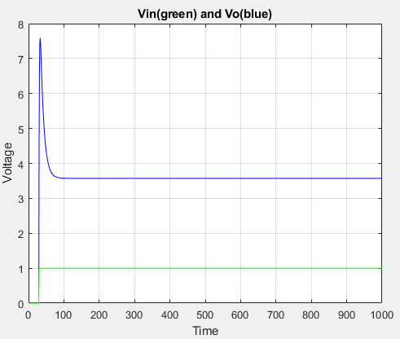

*Figure 6: Plot of Vin and Vo with 1000 steps*

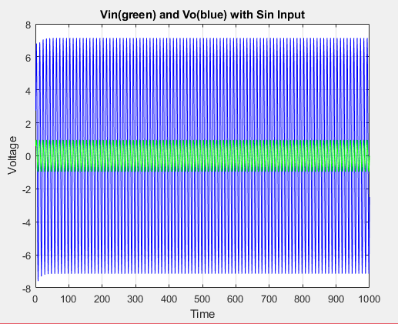

*Figure 6: Plot of Vin and Vo with a sin input*

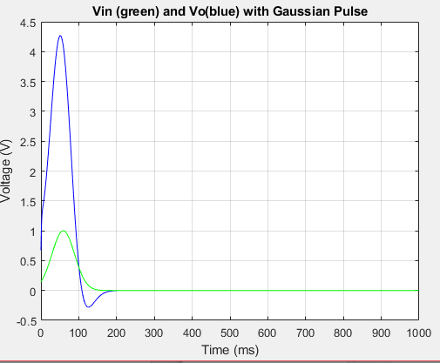

*Figure 7: Plot of Vin and Vo with a Gaussian Pulse as Input*

The frequency plots were then plotted using the different input methods.

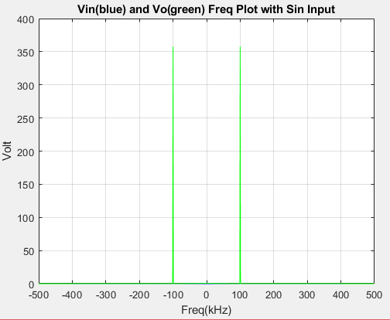  
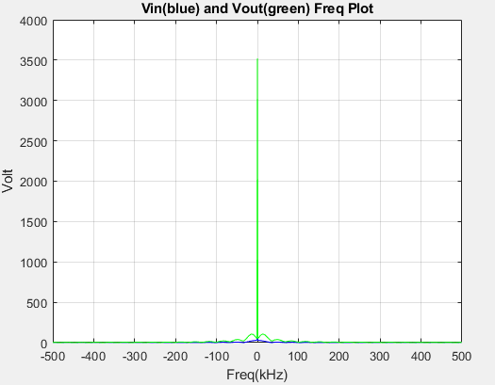

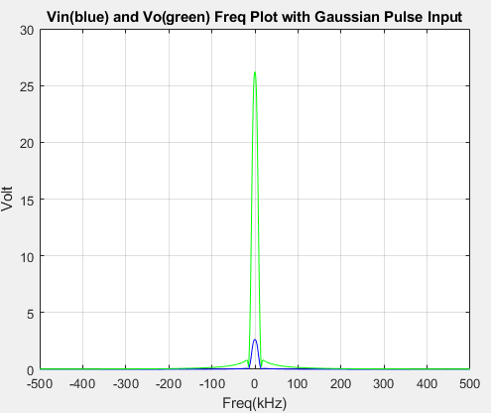

*Figure 8: Freq Plots of all three methods used*

1. When the frequency is decreased, the output magnitude is larger, and the opposite occurs when the frequency is increased, the output magnitude is smaller.
2. The time step increase decreases accuracy.

3.